**פתרון מטלה 1 שפות תכנות**

1.

x,y

(x)

[y]

([x,y])

[x,y,z]

([x,y,z])

((([x,y,z])))

2.

<palindrome> ::= a<palindrome>a | b<palindrome>b |… |z<palindrome>z |<letter>

<letter> ::= a|b|c|...|z|""

3.

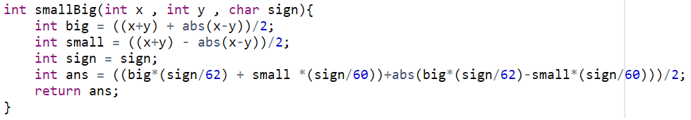

4.

הouter זה בלוק שעוטף את הלולאות בשביל לאפשר יציאה מהירה משתי הלולאות בבת אחת.

כי אם נעשה רק break זה יציאה רק מהלולאת for הפנימית והחיצונית תמשיך לרוץ.

5.

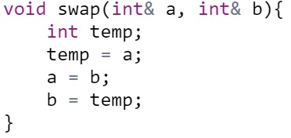

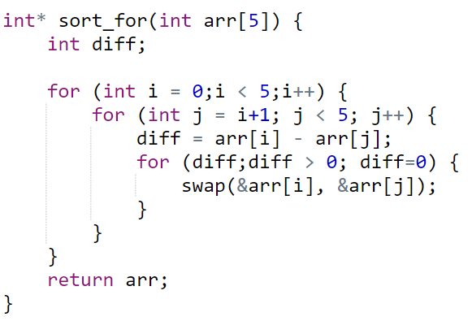א.

ב.

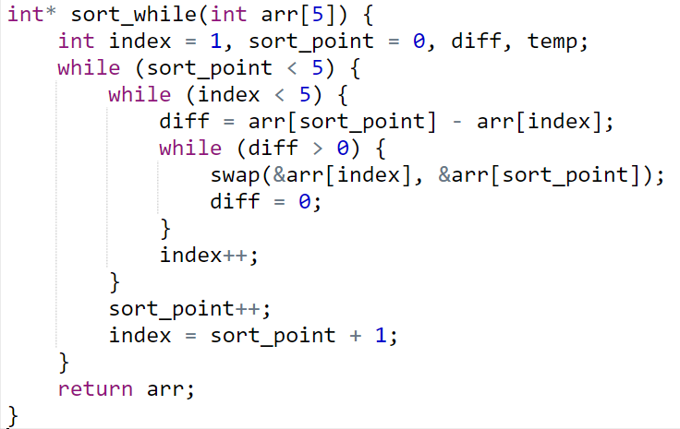

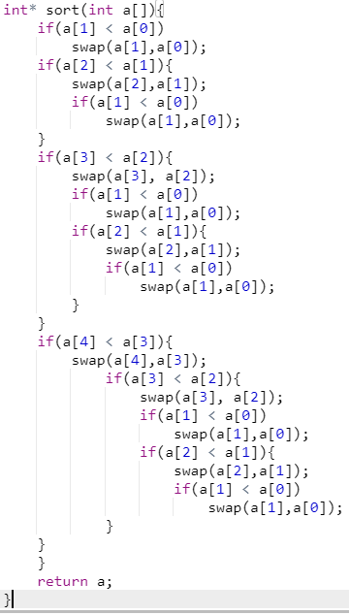ג.

ד. כמו בסעיף ג.

8.

א.

**'''  
After removing number 1 :  
A.__init__  
m of D called  
A.__init__  
m of B called  
m of A called  
m of C called  
A.__init__  
m of B called  
m of A called  
m of A called  
'''**

ב.

**'''  
After removing number 2 :  
<super: <class 'B'>, <D object>>  
m of D called  
<super: <class 'B'>, <B object>>  
m of B called  
m of A called  
m of C called  
<super: <class 'B'>, <B object>>  
m of B called  
m of A called  
m of A called  
'''**

ג.

**'''  
After removing number 3:  
<super: <class 'B'>, <D object>>  
m of D called  
<super: <class 'B'>, <B object>>  
m of B called  
m of A called  
m of C called  
<super: <class 'B'>, <B object>>  
m of B called  
m of A called  
m of A called  
A.__init__  
'''**

ד.

**'''  
After removing number 4:  
<super: <class 'B'>, <D object>>  
m of D called  
<super: <class 'B'>, <B object>>  
m of B called  
m of A called  
m of C called  
<super: <class 'B'>, <B object>>  
m of B called  
m of A called  
m of A called  
A.__init__  
m of B called  
m of A called  
'''**

ה.

**'''  
After removing number 5:  
<super: <class 'B'>, <D object>>  
m of D called  
<super: <class 'B'>, <B object>>  
m of B called  
m of A called  
m of C called  
<super: <class 'B'>, <B object>>  
m of B called  
m of A called  
m of A called  
A.__init__  
m of B called  
m of A called  
A.__init__  
'''**

**שאלות 6-9 מצורף לך הקבצי קוד שלהם בתיקיה**